Web Prototyping Coursework

Onik Noor

K1517267

Contents

Background information 3

Navigation bar 4

Home Page 6

JavaScript Programs Page 7

Comments Page 9

Bibliography 11

# Background information

This coursework will be discussing about the website I have made. Each part will confer each webpage I have created, resulting to six different files. Those files are two HTML files, a CSS file, a JavaScript file and two PHP files. I will be discussing each file in detail in order to show my understanding and to demonstrate my web development skills.

It is worth mentioning that before starting this course, I had no knowledge on how to web development so I will mention all the sources I used to create my website.

The two YouTube links will take you to two different playlists. The first link has taught me how to use HTML and CSS in order to add contents to my website and add styles to look appealing and exciting. The second link is for me understand web client-side using PHP therefore allowing me to connect MySQL database to my website. Using these playlists has made it tranquil for me to tackle problems faced whilst developing my website.

<https://www.youtube.com/playlist?list=PL442FA2C127377F07>

<https://www.youtube.com/playlist?list=PLoYCgNOIyGAB_8_iq1cL8MVeun7cB6eNc>

With JavaScript, this language has been taught on my Programming 1 course. All work is from my knowledge; however, I have used some elements from the course on the website to demonstrate my skills. An example would be I have used Paul Neve’s Jack box images allowing me to toggle both images with a press of a button.

As for plagiarism, I am delighted to say that the codes from all languages is from knowledge. I have used similar formats on YouTube videos and the W3Schools website but none is copied. The only parts that are copied are the links for images, fancy fonts and the paragraphs on the Home page.

The program I used to create my website in Sublime Text. Although this program is timeworn, I have found it most useful due to custom background colours, fonts and wide range of plugins to make my typing experience and web developing easier and faster.

You may have noticed that each HTML file has a script code in line 8. This code is there to allow me to use Live Reload program. What this program does is whenever I am making changes to my website, every time I have saved the file using the shortcut “CTRL + S” the webpage automatically updates which allows me more time efficiency.

As for colour choices, I have noticed that using verbal names e.g. “pink” or “blue” is not the correct practice. Therefore, in order to pick colours for my website I will be using HEX colours. Of course I have not memorised all HEX codes so the website below establishes all colour codes.

<http://www.color-hex.com/>

As for the website I have bought the domain, the link of my website is as follows:

[www.oniknoor.com](http://www.oniknoor.com)

The website is for young adults, I have added bright colours on my website to look more alive and creative instead of using a simple black and white colour combination.

# Navigation bar

With all interactive websites, it is a must of a Navigation bar, allowing easier access to other webpage with a click of a button. The image below is a screenshot of the HTML code of the navigation bar. This is located on line 12 to line 22 on every HTML files.

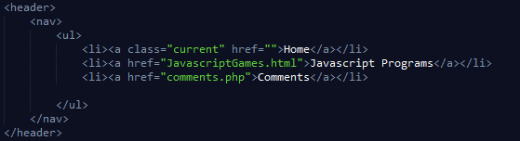

As you can see, I have made four different lists (li) having a reference (href) allowing each access of different HTML files; you may have noticed that one of the “li” have an empty reference, as marked in the screenshot, the reason of this, is that this is the homepage therefore having a link will be pointless as it is the current page shown.

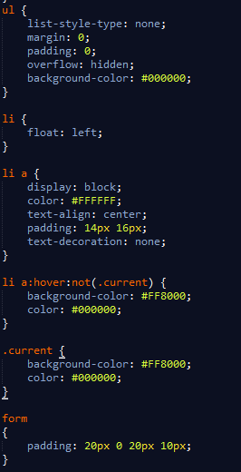With the help on the CSS file I am able to add appealing styles. The screenshot is shown below:

With CSS I am able to customise style to my current liking. With colour I have used HEX codes which I found weird, but heard that it was good practice. As for un-ordered list (ul) I have added no margins, padding and no overflow. This makes the navigation bar appear in the top with no wanted gaps around it. For the list items (li) I have made sure that it goes to the left of the page. This looked appropriate for a navigation bar.

As for listed list for reference “a” (li a) this is the navigation button itself. I have made in blocks to look appealing, with the colour orange (note in HEX code). I have aligned the font to the centre as keeping it in default looked strange. I have added padding so there is space between the letters and colour so the user can see where the navigation button is instead of just letters.

As for the “li a: hover: not (. current)” this allows the navigation to change colour when the mouse cursor is placed on the non-current page. This looked more alluring for the navigation bar.

As for the current, I have added the orange background so whenever the page is selected the corresponding navigation button will be orange in order to specific which page is nominated.



The image above is showing the result with the combination of HTML listed items and the CSS style changes. It is also confirmed that whenever I hover the mouse cursor to the “Comments” navigation bar it also changes to orange, this is shown below:

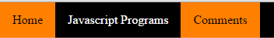

# Home Page

With the homepage I have added an excited heading that has been given by Google.



Not only it is a fixed colour but it is also an animation compatible to most internet browsers. On the first link of the bibliography there is a link of the website showing the tutorial on how to make this heading without the user installing the font itself.

With the screenshots above it shows how making the font on my page possible. The first screenshot shows the reference in order to me to access the font itself using a source. The second screenshot shows how I put it in action as a heading (h1).

I have broken down the page into three different sections, to stop the website from looking plain with paragraphs going across the page, to do this each paragraph is put in a section.

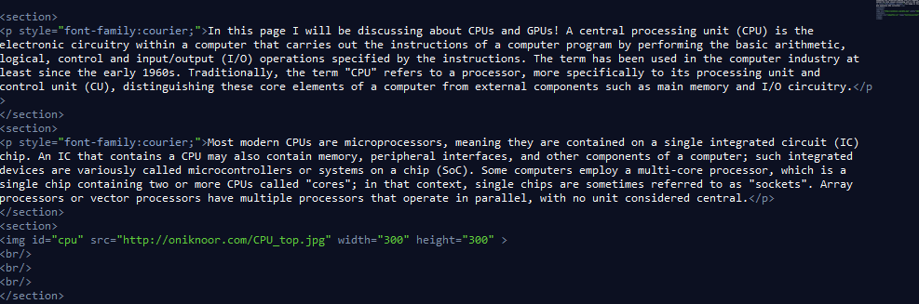Of course if I only put section it will only go down the page this is why I have used CSS that allows me to configure the sections. You may have noticed that the font of the paragraphs is not default instead they are “courier” the reason why I picked this font is because it gives off a robotic feel on the website as this part of the web page is about CPU and GPU, I thought it was appropriate font.

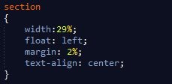With this screenshot on my CSS file, the width is 29%, floating to the left hand side, this allows me to add three different sections across the page. As for the margins this allows space between each sections so it does not look like it constricted together. I have also made the text align towards the centre as aligning it as default looks too unprofessional.

# JavaScript Programs Page

This web page demonstrates my JavaScript skills I have learnt so far at my time at Kingston University. As for the JavaScript page I have added the navigation bar, a heading and a couple of paragraphs. As this is only strictly on JavaScript I have decided to make it nice and simple.

Of course for JavaScript code to work in a HTML web page you have to put a script part of the code, this script is in JavaScript version and is located just before the closing tab of body (</body>). I have decided to put the JavaScript code in a separate file which in my opinion is easier.

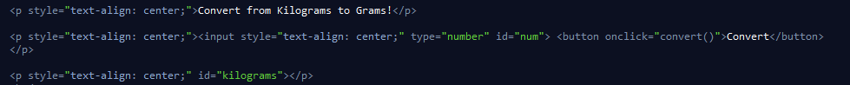The first program is conversion, similar to an activity on IT Toolbox, but this time in JavaScript language instead of PHP.

At first I have put a paragraph giving the user an idea on what the program will do, for this example I will convert kilograms to grams.

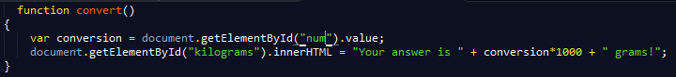I therefore added a textbox and a button in the same line, I have made the type of textbox number only so the user cannot add any letters and symbols and also added an id named “num”. With the button it contains the word “Convert” and whenever the button is pressed the function “convert ()” will take action. Notice that paragraph three with an ID “kilograms” is left empty.

The screenshot above shows the convert function. I have made a variable which represents a value of which what the user put on the textbox. With this variable I can use it in my advantage. On the second line of my function, it is programmed that with the empty HTML element (ID “kilograms”) it should change to the following String including the variable which is multiplied by 1000. As this is a method to convert from Kilograms to grams. The following screenshots will show how it should act.

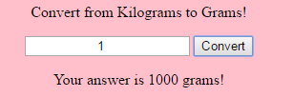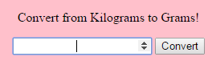

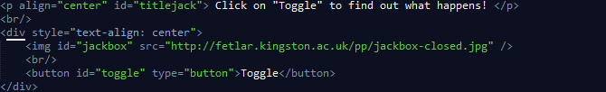My second JavaScript program was a toggle between two images with a single button. This took long as at first it did not work first time when using my NoobLab code therefore I had to do some research.

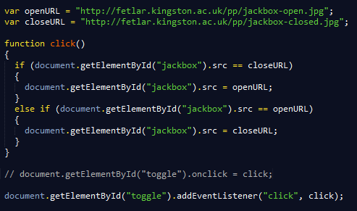To start with I have added a paragraph encouraging the user to press the button to “see what happens”. With a break (br/>) I have added a division (div) which is a section of a website. On this section I have put an image (From Paul Neve) with a “Toggle” button underneath.

At first I have made two variables representing two different images. With the function it checks the URL of the image file, when the “toggle” button is pressed the image changes to another image and vice versa. At first I thought a simple “onclick” method would work, (which is on comment form in the screenshot) this method I used on one of my NoobLab exercise which works perfectly but in my website it did not. After searching the web, I have come across EventListener. EventListener was helpful as when the event happens (the “toggle” button pressed) the function will take place. The syntax is as follows: document. getElementById (“”). addEventListener (event, function, useCapture);

In my code only two parameters were needed, (event and function) the third parameter is left blank as it was as no use. The event is “click” as the event will take place when the HTML element ID “toggle” is clicked. The function will be “click” as that is the function I want to use for this scenario.

As a result whenever the button is clicked the image changes and once pressed again it changes back which is what I wanted.

# Comments Page

This part of the website shows my understanding of PHP and MySQL. As two PHP file is used I will discuss both.

The first PHP file I will discuss is named “connect.php”:

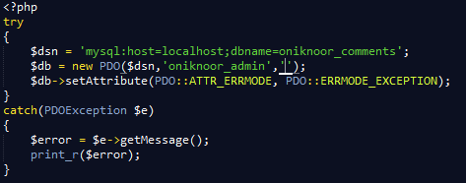The code above is PHP code programmed to connect to my database on SQL, I have decided to use the PDO (Php Data Objects) method as it is more secure and easier to use in my opinion. On the try method, I have made two variables. The first is $dsn which going to MySQL, finding a host which in this case would be localhost, connecting to a database named oniknoor_comments.

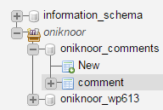The screenshot on the right shows that using phpMyAdmin I have created a database oniknoor_comments. On this database I have made three fields. The screenshot below will show what three fields I have made on the database.

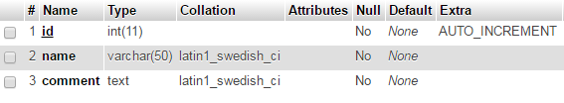

The three fields are ID, name and comment. ID is randomly created whenever someone creates a comment. The name field is where the user can put their name, and as for comment this is where the user put their comment.

On the $db variable I have made a PDO using the following syntax:

**PDO:__construct** ( string $dsn [, string $username [, string $password [, array $options]]] )

As being the username being oniknoor_admin, as for the password it is not normally blank but for the purpose of security I have made it blank for the case to show my screenshot. As for the third line of my code, it is a error message display just in a case where my login have not been successful.

As for the connection is successful now I need to use this database, as a result I thought using a comment section will demonstrate my PHP programming skills.

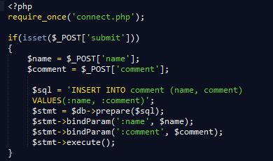The screenshot on the right shows parts of my second PHP file named “comments.php” the first line tells us to execute my first PHP code, this is there so I can login to my SQL database and go to the corresponding database. Afterwards I have programmed that if the submit command occurs the following code will occur.

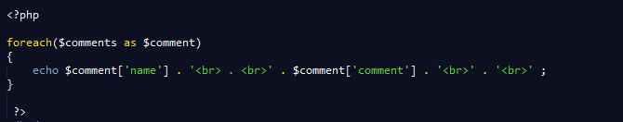I have made two variables name “$name” and “$comment” representing both name and comment posts. Underneath I have programmed that the “Name” textbox should go to the “Name” field and comment textbox should go to the “comment” database. Using the bindParam method. I will now discuss how I could display the comments on the webpage.

The screenshot above is a screenshot after most HTML elements. I have used a foreach loop so for every comment available on the database it will display it using “echo”. You may have noticed that I have added <br>, this breaks both contents of the fields, so Name will be at top and below it will be the comment. The screenshot below shows a test run to see if it works. Feel free to add a comment to test it out!



# Bibliography

<https://developers.google.com/fonts/docs/getting_started#Optimizing_Requests> – Tutorial of the Home Page Heading

<https://en.wikipedia.org/wiki/Central_processing_unit> – Paragraph 1 and 2 of Home Page

<https://en.wikipedia.org/wiki/Graphics_processing_unit> – Paragraph 2 and 3 of Home Page

<http://www.w3schools.com/js/js_htmldom_eventlistener.asp> – Syntax of EventListener

<http://php.net/manual/en/pdo.construct.php> – Syntax of PDO